Registration of new market participants with ElCom

In order to register a market participant with ElCom, the market participant must have a CH-Login. The following document describes how to obtain a CH-Login.

Once you have set up a CH-Login, you can register the market participant with ElCom as follows.

Click here to log in: https://www.gate.elcom.admin.ch/regtool/index.html

The CH-Login screen appears again, and now you can log in with the CH-Login you created.

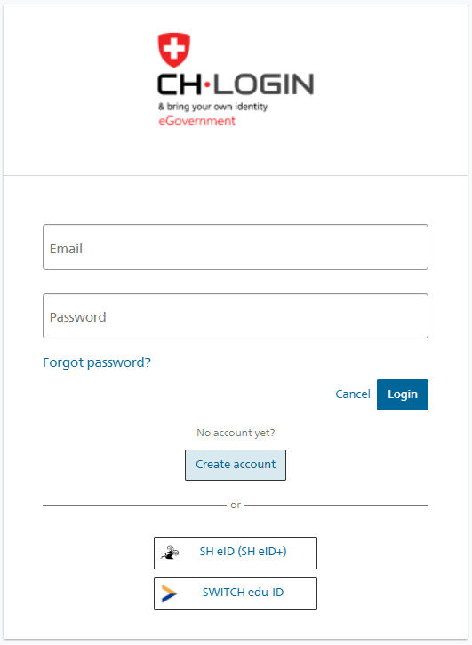

You then continue the login process with two-factor authentication (email or SMS).

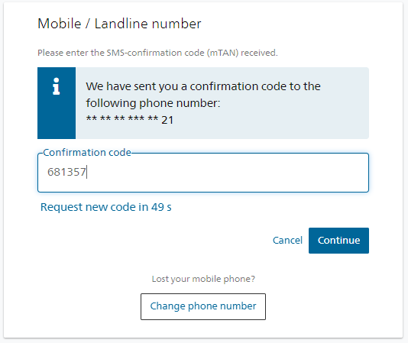

Once you have logged in with your CH-Login, the following window appears. The only information you need to complete here is the comment; all other details are automatically filled in. You must tick the box for 'I accept the terms of use' or you will not be able to continue with registration.

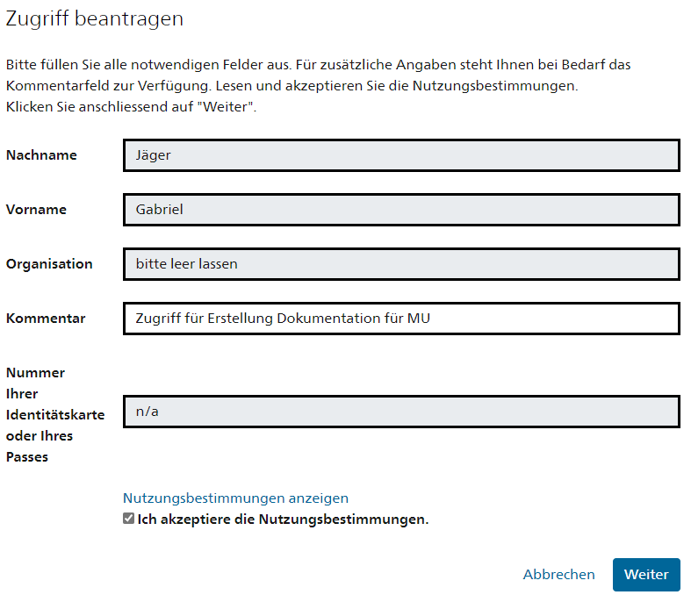

The following notification then appears. This gives you access to the registration tool.

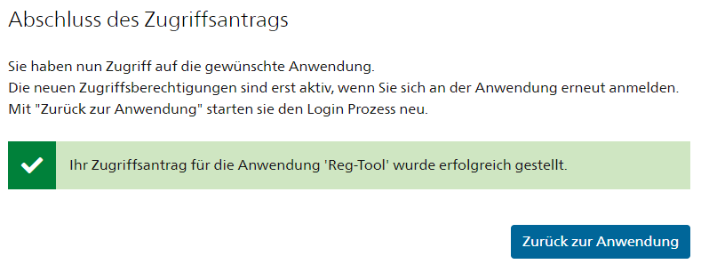

If you press the 'Back to the application' button, the following window appears.

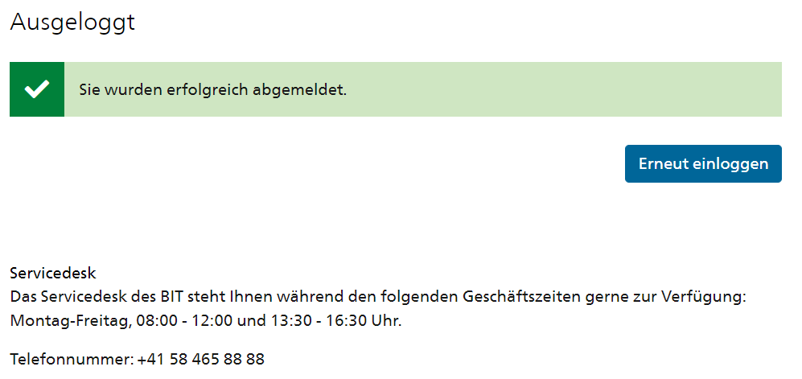

Press 'Log in again'. The login screen appears again. Here you can log in again.

To log in again, you have to use the two-factor authentication (email or SMS) once more.

Now that you have access to the application and have logged in again, you can register the market participant.
Once you have logged in, the following screen appears. Here you have to enter various details about the company (legal form, name of market participant, etc.).

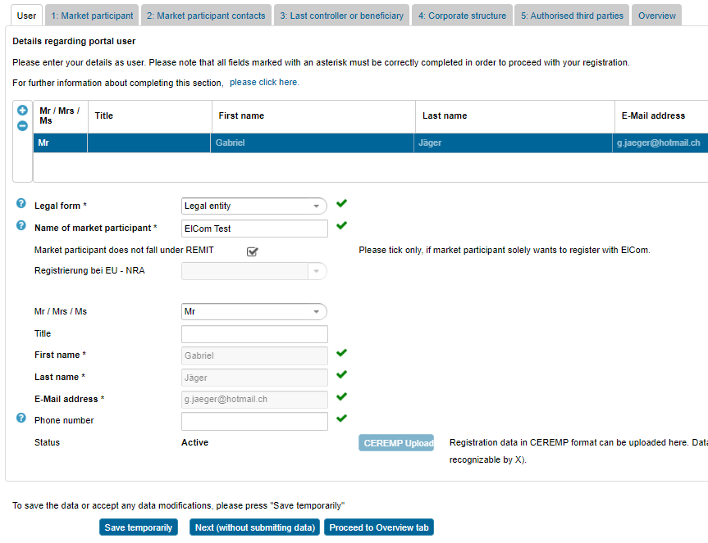

Detailed instructions regarding the individual tabs (User, 1. Market Participant, 2. Market participant contacts, etc.) can be found in the following document (in German and French):

Once you have completed all tabs and arrived at the 'Overview' tab, you are almost there. If validation is shown everywhere as 'OK' in green, you can press the 'Submit registration data' button on the bottom left.

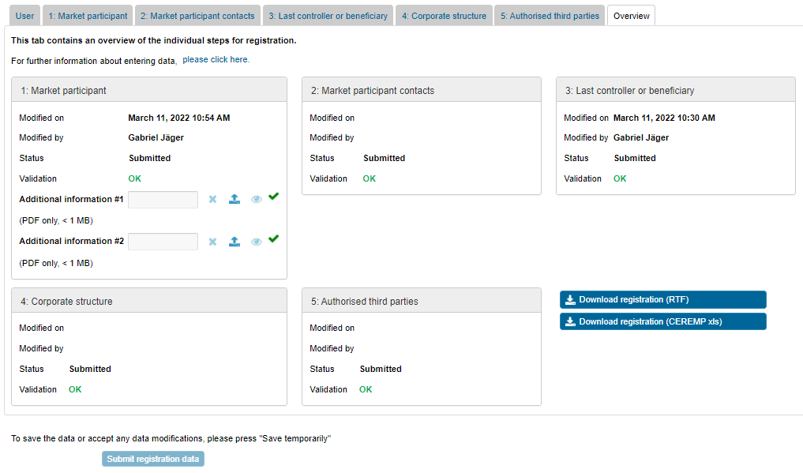

The following information window then appears. The registration process is now complete. ElCom's Market Surveillance Section will check the data submitted and contact you.

